Lab 08 – Exercise 1: ArrayList Operations
Aim: To demonstrate how to store and process integers using Java's ArrayList.
Source Code
Main.java

package lab08collections;

import java.util.ArrayList;
import java.util.Collections;

public class Main {

public static void main(String[] args) {

// Store 10 integers in an ArrayList
ArrayList<Integer> numbers = new ArrayList<>();

numbers.add(15);
numbers.add(8);
numbers.add(23);
numbers.add(4);
numbers.add(17);
numbers.add(9);
numbers.add(31);
numbers.add(12);
numbers.add(6);
numbers.add(20);

// Calculate the sum
int sum = 0;

for (int number : numbers) {
sum += number;
}

// Find the maximum value
int maximum = Collections.max(numbers);

// Print the original list and results
System.out.println("Original list: " + numbers);
System.out.println("Sum: " + sum);
System.out.println("Maximum: " + maximum);

// Reverse the list
Collections.reverse(numbers);

System.out.println("Reversed list: " + numbers);
}
}
Output
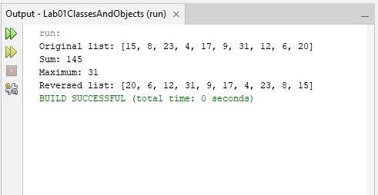
Explanation: An ArrayList<Integer> was used to store ten integers. A loop calculated their sum, while Collections.max() identified the largest value. The Collections.reverse() method was then used to reverse the list.
Conclusion: The exercise demonstrated how Java collections simplify storing, accessing and manipulating groups of values.

Exercise 2: Removing Duplicates Using a Set
Aim: To demonstrate how a Java Set removes duplicate values from a collection.
Source Code
Main.java

package lab08collections;

import java.util.ArrayList;
import java.util.LinkedHashSet;
import java.util.List;
import java.util.Set;

public class Main {

public static void main(String[] args) {

// Create a list containing duplicate names
List<String> names = new ArrayList<>();

names.add("Tendai");
names.add("Brian");
names.add("Angela");
names.add("Tendai");
names.add("Farai");
names.add("Brian");
names.add("Grace");
names.add("Angela");

System.out.println("Original names: " + names);

// Remove duplicates while preserving insertion order
Set<String> uniqueNames = new LinkedHashSet<>(names);

System.out.println("Names without duplicates: " + uniqueNames);
System.out.println("Number of unique names: "
+ uniqueNames.size());
}
}
Output
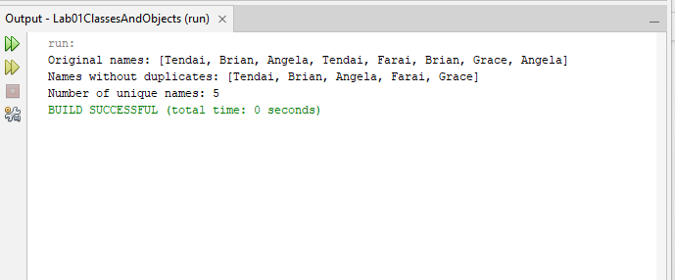
Explanation: An ArrayList was used to store names, including duplicates. The list was then passed to a LinkedHashSet, which retained only unique names while preserving their original insertion order. The resulting set and its size were displayed.
Conclusion: Sets are useful when unique values are required. A LinkedHashSet also preserves insertion order, making the output predictable.

Exercise 3
Aim: To implement a generic stack using ArrayList and demonstrate its main operations.
Source Code
GenericStack.java

package lab08collections;

import java.util.ArrayList;
import java.util.NoSuchElementException;

public class GenericStack<T> {

private ArrayList<T> items = new ArrayList<>();

// Add an item to the top of the stack
public void push(T item) {
items.add(item);
}

// Remove and return the top item
public T pop() {
if (isEmpty()) {
throw new NoSuchElementException("Stack is empty.");
}

return items.remove(items.size() - 1);
}

// View the top item without removing it
public T peek() {
if (isEmpty()) {
throw new NoSuchElementException("Stack is empty.");
}

return items.get(items.size() - 1);
}

// Check whether the stack is empty
public boolean isEmpty() {
return items.isEmpty();
}

// Return the number of items
public int size() {
return items.size();
}
}
Main.java

package lab08collections;

public class Main {
public static void main(String[] args) {

GenericStack<String> stack = new GenericStack<>();

System.out.println("Is stack empty? " + stack.isEmpty());

stack.push("Java");
stack.push("OOP");
stack.push("Generics");

System.out.println("Stack size: " + stack.size());
System.out.println("Top item: " + stack.peek());
System.out.println("Removed: " + stack.pop());
System.out.println("Top item after pop: " + stack.peek());
System.out.println("Is stack empty? " + stack.isEmpty());
}
}
Output
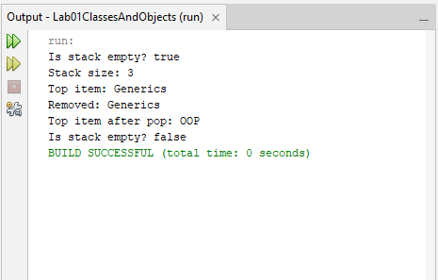
Explanation: The program stores elements in an ArrayList. Items are added and removed from the end of the list to follow the LIFO principle. Generics allow the stack to work with different reference types.
Conclusion: The exercise demonstrates generics, collections, and stack operations in Java.

Exercise 4
Aim: To count the frequency of words in a paragraph using a Map and sort the results by frequency in descending order.
Source Code
Main.java

package lab08collections;

import java.util.HashMap;
import java.util.Map;
import java.util.Scanner;
import java.util.ArrayList;
import java.util.Comparator;
import java.util.List;

public class Main {
public static void main(String[] args) {
Scanner input = new Scanner(System.in);

System.out.println("Enter a paragraph:");
String paragraph = input.nextLine().toLowerCase();

// Remove punctuation and split the paragraph into words
paragraph = paragraph.replaceAll("[^a-z0-9\\s]", "");
String[] words = paragraph.trim().split("\\s+");

// Count how many times each word appears
Map<String, Integer> frequency = new HashMap<>();

for (String word : words) {
if (!word.isEmpty()) {
frequency.put(word,
frequency.getOrDefault(word, 0) + 1);
}
}

// Convert map entries to a list so they can be sorted
List<Map.Entry<String, Integer>> entries =
new ArrayList<>(frequency.entrySet());

entries.sort(
Comparator.comparing(Map.Entry<String, Integer>::getValue)
.reversed()
.thenComparing(Map.Entry::getKey)
);

System.out.println("\nWord frequencies (highest first):");

for (Map.Entry<String, Integer> entry : entries) {
System.out.println(
entry.getKey() + ": " + entry.getValue()
);
}

input.close();
}
}
Output
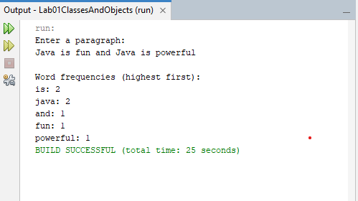
Explanation: The program reads a paragraph, normalises the words, and stores their frequencies in a HashMap. It converts the map entries into a list and sorts them by frequency, using alphabetical order to break ties.
Conclusion: The exercise demonstrates how Java maps can store and update word counts and how comparators can sort the results.

Exercise 5
Aim: To implement a generic bubble sort method that sorts arrays of different comparable object types.
Source Code
Bubblesort.java

package lab08collections;

public class BubbleSort {

public static <T extends Comparable<T>> void bubbleSort(T[] arr) {
int n = arr.length;

for (int i = 0; i < n - 1; i++) {
for (int j = 0; j < n - 1 - i; j++) {

// Compare neighbouring elements
if (arr[j].compareTo(arr[j + 1]) > 0) {
T temp = arr[j];
arr[j] = arr[j + 1];
arr[j + 1] = temp;
}
}
}
}
}
Main.java

package lab08collections;

import java.util.Arrays;

public class Main {
public static void main(String[] args) {

// Test using Integer objects
Integer[] numbers = {45, 12, 78, 3, 29};

System.out.println("Integers before sorting: "
+ Arrays.toString(numbers));

BubbleSort.bubbleSort(numbers);

System.out.println("Integers after sorting: "
+ Arrays.toString(numbers));

// Test using String objects
String[] names = {"Tendai", "Brian", "Angela", "Farai"};

System.out.println("\nNames before sorting: "
+ Arrays.toString(names));

BubbleSort.bubbleSort(names);

System.out.println("Names after sorting: "
+ Arrays.toString(names));
}
}
Output
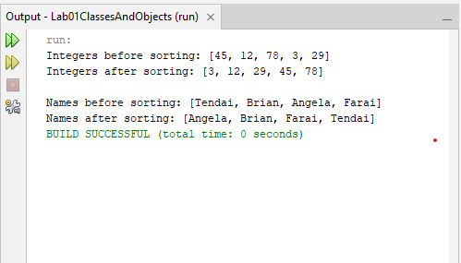
Explanation: The program uses a generic method restricted to types implementing Comparable. It compares adjacent elements with compareTo() and swaps them until the array is sorted in ascending order.
Conclusion: The exercise demonstrates generic methods, type bounds, interfaces, and sorting. Using Integer[] instead of int[] allows the generic method to work with numeric values.

